Year 12 Physics

Circular Motion, Gravity
/44

and Equilibrium Test

2022

NAME:

Suggested Time 55 minutes

INSTRUCTIONS TO CANDIDATES

- Answer all questions in the spaces provided.
- Questions containing the word ‘estimate’ require you to provide some data.
- All numerical answers must be evaluated and not left in fractional form.
- Give numerical answers to three significant figures, however estimates should be given to a maximum of two significant figures.
- Credit may be obtained for method and working out despite an incorrect final answer, providing your solution to the problem is clearly set out.
- Total marks = 44

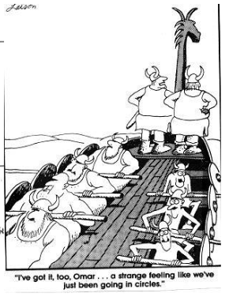

- Imagine that two new planets have been discovered in another solar system, call them X and Y. They both have the same radius but planet X has twice the mass of planet Y. On the diagram below, draw in the gravitational fields for each planet. (2 marks)

X Y

- 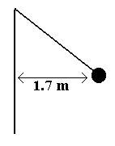A hammer thrower has gradually increased the speed of his hammer so that it completes ten revolutions in 22.0 s.
The hammer of mass 7.26 kg may be considered to be moving in a horizontal circle of 1.70 m radius.
What force is exerted on the hammer thrower’s arm?
Include a diagram in your answer. (5 marks)

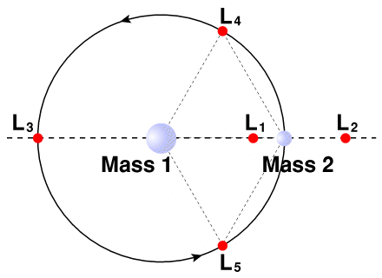
- The James Webb Space Telescope (JWST) is the most powerful infrared telescope ever launched into space, superseding the Hubble Space Telescope. It was launched on December 25, 2021, and reached its destination – a point in space designated ‘L₂’ - on January 24, 2022. At L₂, JWST will be on the side of the Earth that is farther from the Sun, and it will essentially orbit the Sun due to the combined gravitational attraction of the Sun and the Earth. L₂ is located approximately 1.50 x 10⁶ km from Earth.

  - Find the gravitational field strength at JWST at L₂ due to the Earth: (1 mark)

  - Find the gravitational field strength at JWST at L₂ due to the Sun: (1 mark)

  - State the total centripetal acceleration on JWST at L₂: (1 mark)

  - Hence, show that the orbital period of JWST around the Sun is approximately 1 year: (3 marks)

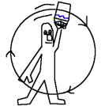
- Estimate the minimum speed required to swing a bucket of water in a vertical circle so that the water remains in the bucket. (4 marks)

- The mass of Jupiter is 1.90 x 10²⁷ kg and its diameter is 142 984 km.
What altitude would a satellite have if its orbital speed is 3.00 x 10⁴ ms⁻¹? (4 marks)

- Calculate the orbital radius of a geosynchronous satellite. (3 marks)

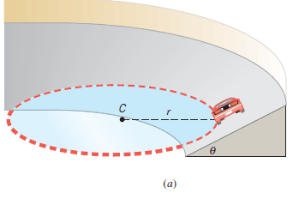
- Consider a vehicle travelling on a banked curve. Demonstrate that the design speed of the curve (the speed at which the car can navigate the curve without relying upon friction) can be given as: . Your answer must include relevant diagram(s). (3 marks)

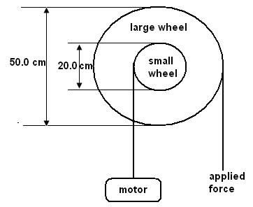
- A windlass is a simple machine that consists of two concentric wheels of different diameter than can be used to lift heavy weights. A home mechanic is using a windlass to lift a 225 kg engine out of his car. The smaller wheel of the windlass has a diameter of 20.0 cm and the larger wheel 50.0 cm. Calculate the minimum force necessary to lift the engine out of the car. (2 marks)

- A car of mass 545 kg is travelling on a roller coaster.
  - Find the force exerted by the track on the car when it is at the bottom of a dip of radius 7.05 m and travelling at a speed of 8.5 ms⁻¹. Include a force diagram in your answer. (3 marks)

  - Calculate the apparent weight of a 60.0 kg teenager on the ride at the bottom of the dip. (2 marks)
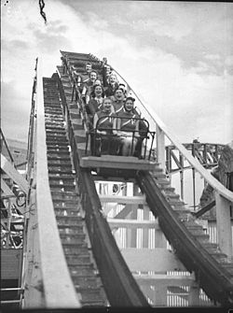
- A 6.0 m uniform beam of mass 25 kg is suspended by a cable as shown. An 85 kg object hangs from one end. Calculate the tension in the cable and the reaction force of the wall on the beam. (10 marks)

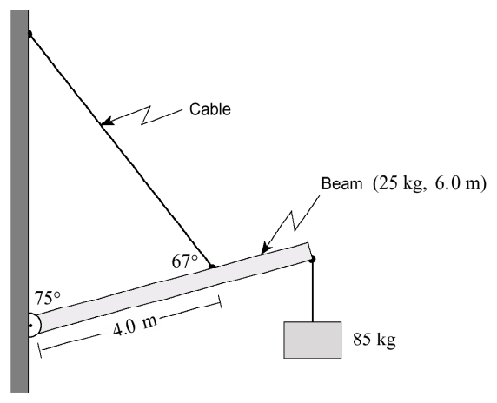

Spare Page:

